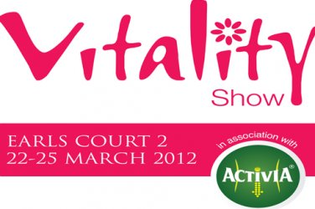

Event Name:
Event Venue:
Event Date: | Booth Number:

Contractor Name: | Exhibiting Name:
Company: | Position:
Signature: | Signature:
Task / Subject: | Hazard (s): | Who’s at Risk:  Exhibitors, Contractors, Subcontractors, Visitors, Organizers, Venue Staff, Young / New / Inexperienced Staff, General Public, Disabled, Lone Workers, Children, Other (specify) | Risk Level:  Frequency / Severity /  Maximum Loss / Probability | Precautions or Control Measures Required:  (State existing measures if adequate) | Comments:
-------------------------------------------------------------------------------------------------------------------------------------------------------------------------------------------------------------------------------

